Chalice McKnight
Lamar University
EDLD 5317: Resources Digital Environments
July 15, 2026
From Passive Learners to Active Historians: Using Digital Portfolios to Foster Student Ownership Through Blended Learning

Introduction
During our Texas Revolution unit, a student reviewed her digital portfolio, examining her assessment data and reflection notes instead of just asking for her grade. She told a classmate, "I think I understand the major causes of the Texas Revolution, but I’m still confused about the Law of April 6, 1830, and why it made tensions worse. I want to go back through my notes and revisit the station activities before the next test."
To many educators, this interaction might seem ordinary. For me, it represented one of the most meaningful moments of the school year. The student was no longer waiting for me to identify what she needed to improve. Instead, she independently evaluated her understanding, recognized a learning gap, and created a plan to improve before I ever spoke with her. That moment represented exactly the type of learner I hoped to develop, not one who depended solely on teacher feedback, but one who could monitor her own progress and take ownership of her learning.
Experiences like this demonstrate the power of digital portfolios when intentionally included in instruction. Instead of just storing assignments, digital portfolios help students analyze evidence of learning, reflect on their progress, set goals, and track growth over time. When students practice these skills regularly, learning becomes a process, not just a checklist of finished tasks.
We often talk about student ownership, but true ownership cannot be given; it must be cultivated. It emerges when students regularly engage in reflection, decision-making, and problem-solving about their learning. Effective integration of technology in this process is not about the tools themselves; it is about making student thinking visible and supporting authentic reflection, so students take responsibility for their learning.
Hughes and Roblyer (2023) argue that educational technology is most effective when it is nearly invisible within the learning environment, functioning as a support for deeper engagement rather than as the main focus. Following this philosophy, in my classroom, technology is integrated to document student learning, encourage reflection, and support student agency, rather than being a goal in itself.
This article is intended for classroom teachers, instructional coaches, and campus leaders seeking practical strategies to increase student engagement through meaningful technology integration.
Through blended learning, station rotation, digital portfolios, and structured reflection, I have witnessed students transition from passive recipients of information to active participants in their own educational journey.

The Problem: Learning as Compliance
One of the greatest challenges facing today’s classrooms is not a lack of technology. Instead, students tend to view learning as a series of assignments completed for grades rather than as opportunities for growth. Many middle school students are conditioned to ask questions such as, "What did I make?" or "Is this for a grade?" before they truly understand the content.
In many traditional instructional settings, students depend on teachers to identify strengths, diagnose weaknesses, and determine the next steps for improvement. Although this approach can deliver content effectively, it often limits student independence and reduces opportunities for meaningful self-directed learning. Students become dependent on external feedback rather than developing the ability to evaluate their own understanding.
Teachers face similar challenges. Every day, educators balance increasing expectations that include differentiating instruction, improving engagement, analyzing assessment data, preparing students for state assessments, integrating technology, and meeting the needs of increasingly diverse learners. When not intentionally aligned with instructional goals, technology initiatives risk becoming extra responsibilities rather than meaningful supports for teaching and learning.
The challenge is not finding more technology; it is intentionally designing learning environments where students actively construct knowledge, reflect on their thinking, and assume responsibility for their learning. As Dewey argued, authentic learning occurs when students actively engage in meaningful experiences, reflect on them, and connect new understandings to prior knowledge (as cited in Hughes & Roblyer, 2023). Simply providing students with digital tools does not accomplish this goal. Instructional design must intentionally create opportunities for reflection, collaboration, inquiry, and continuous improvement.
Roger Schank's work in cognitive science further supports this perspective. Schank argues that meaningful learning occurs through experience, problem solving, and reflection rather than passive memorization (Education Futures, 2011). Students remember what they actively do, analyze, and apply. These ideas reinforce the belief that technology should support, rather than replace, cognitive engagement.
To address this challenge, I developed an instructional model that combines blended learning, station rotation, and digital portfolios. Together, these strategies create a learning environment in which students regularly analyze their progress, collaborate with peers, and use evidence to make informed decisions about their learning. Instead of viewing learning as a completed assignment, students begin to see it as a continuous process of growth.

The Innovation: Blended Learning and Digital Portfolios
My innovation blends blended learning, digital portfolios, and project-based learning in a seventh-grade Texas History class. Instead of relying solely on whole-group instruction, students rotate through stations that allow them to engage with content, collaborate, and reflect. The classroom has three instructional stations. Students rotate through a teacher-led station for instruction, a collaborative station to analyze history with classmates, and an independent digital station to complete activities and reflections for their digital portfolio. Each station has a role in supporting a student-centered environment.
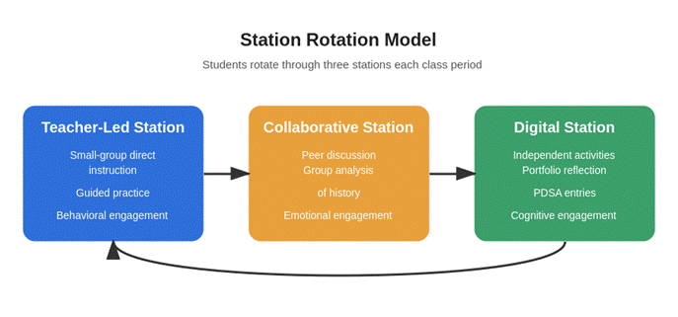
Figure 1. The Station Rotation Model: students rotate through three stations each class period.
Unlike a traditional collection of assignments, the digital portfolio functions as a living record of student growth. Students upload learning artifacts, analyze assessment data, establish learning goals, and complete structured reflections using the Plan-Do-Study-Act (PDSA) cycle. As students revisit their portfolios throughout the unit, they begin to identify patterns in their performance, recognize areas of strength, and create action plans for continued improvement.
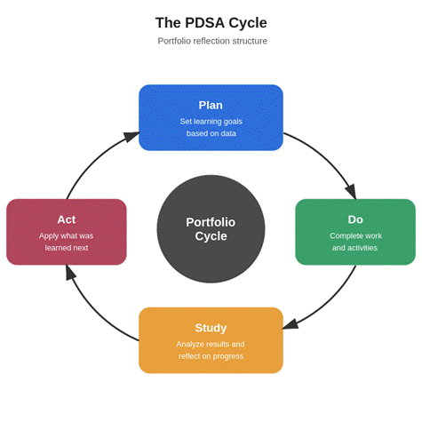
Figure 2. The PDSA Cycle as a portfolio reflection structure: students plan goals, complete work, study their results, and act on what they learn.
The portfolio also supports authentic learning. Students demonstrate knowledge beyond tests. They collect historical investigations, collaborative work, products from stations, written reflections, presentations, and project-based assignments. These pieces track growth and help students connect content to bigger ideas and their experiences. Over time, students shift from focusing on grades to monitoring growth. They begin asking, "What do I still need to learn?" This is a significant outcome of this innovation.

Theoretical Grounding: Why This Approach Works
This model is based on constructivist theory, which says learning is active. Students build new understanding through experience, reflection, and social interaction. They connect new ideas to what they already know, not just receive information. Vygotsky’s theory supports the collaborative parts of the station rotation model. With structured peer talks and teacher help, students work in their Zone of Proximal Development and improve their understanding of history.
Bruner’s theory of scaffolded learning matters too. Students do not become reflective learners overnight. They start with prompts, modeling, and feedback, which decrease as they grow. This gradual release helps reflection become part of learning rather than a separate task.
Piaget’s cognitive development theory supports the use of digital portfolios. Learners build knowledge through experiences. Portfolios let them document, review, and notice how their understanding changes over time.
Roger Schank extends these constructivist ideas through cognitive science, arguing that meaningful learning occurs through authentic experiences, storytelling, and reflection rather than memorization alone (Education Futures, 2011). Students remember what they actively experience, analyze, and apply. By encouraging students to document their learning journey, explain their thinking, and reflect on both successes and challenges, digital portfolios support the type of meaningful learning Schank describes.
Hughes and Roblyer (2023) similarly argue that technology should function as a cognitive tool rather than simply delivering information. When technology becomes nearly invisible within instruction, students focus less on the tool itself and more on the thinking, reflection, and problem-solving it supports. This philosophy guides every aspect of my innovation plan.

Student Engagement: More Than Participation
Student engagement extends far beyond keeping students busy. Fredricks, Blumenfeld, and Paris (2004) describe engagement as consisting of three interconnected dimensions: behavioral, emotional, and cognitive. Effective instructional design addresses all three.
The station rotation model naturally supports behavioral engagement by providing movement, varied learning experiences, and clearly defined expectations. Students remain actively involved because instruction shifts throughout the class period rather than relying on extended whole-group lectures.
Emotional engagement develops through collaboration, meaningful relationships, and frequent opportunities for discussion. Working with classmates encourages students to share ideas, ask questions, and learn from multiple perspectives while building confidence in their understanding.
The greatest transformation occurs in cognitive engagement. Digital portfolios require students to analyze assessment results, reflect on misconceptions, establish learning goals, and monitor their own progress. These activities move students beyond remembering information toward evaluating their own thinking and making informed decisions about future learning.
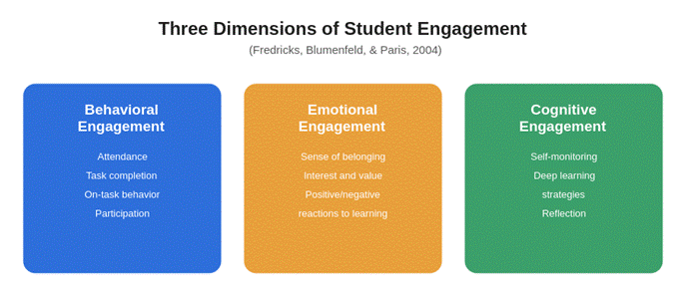
Figure 3. Three dimensions of student engagement (Fredricks et al., 2004).
Lei et al. (2018) found a moderately strong positive relationship between student engagement and academic achievement across 69 independent studies involving nearly 200,000 participants. Among the three dimensions of engagement, cognitive engagement, including self-monitoring, reflection, and deep learning strategies, demonstrated the strongest relationship with academic success. These findings reinforce the importance of instructional models that encourage students to think critically about their own learning rather than simply complete assignments.
The station rotation model and digital portfolios intentionally support all three dimensions of engagement, creating an environment in which students actively participate, collaborate meaningfully, and develop the reflective habits associated with long-term academic success.

Learning Through Reflection: Where Ownership Begins
One of the most powerful aspects of digital portfolios is the opportunity they provide for intentional reflection. Early in the implementation process, many students struggled to evaluate their own learning. Their reflections were often limited to reporting a grade or stating whether an assignment was "easy" or "hard." Although these responses acknowledged performance, they rarely demonstrated an understanding of why students succeeded or struggled.
Developing meaningful reflection required deliberate instruction. I modeled my own thinking, provided sentence stems and guiding questions, and used think-aloud strategies to demonstrate how effective learners analyze their progress. Over time, students became more comfortable examining their work beyond the final score.
Instead of writing, "I made a 70," students began explaining why they struggled, identifying misconceptions, describing strategies they used to improve, and setting specific goals for future learning. Reflection gradually became part of the learning process rather than just another assignment.
As students regularly reviewed assessment data, revisited previous work, and established learning goals, they began demonstrating habits associated with self-directed learning. Rather than relying solely on teacher feedback, students increasingly drew on evidence in their portfolios to evaluate their understanding and determine their next instructional steps. The shift from asking, "What did I make?" to asking, "What do I need to learn next?" became one of the clearest indicators that students were beginning to take ownership of their learning.
Research supports these observations. Garcia (2025) examined the use of self-coded digital portfolios with 176 undergraduate computing students enrolled in a web design and development course. Although the study was conducted in a higher education setting rather than a middle school classroom, the findings demonstrated that students who actively maintained digital portfolios experienced increased engagement, reflection, and ownership of their learning over time. While the educational contexts differ, the study reinforces the broader principle that thoughtfully designed digital portfolios can strengthen student agency when paired with intentional instructional design.
Similarly, Lam (2022) found that e-portfolios support both self-regulated and co-regulated learning by encouraging students to engage in ongoing reflection, monitor their progress, and make informed decisions about future learning. Although these studies represent different educational settings, their findings closely align with what I observed in my classroom as students developed greater confidence, independence, and ownership throughout the implementation process.

Lessons Learned
Implementing digital portfolios reinforced several important lessons about meaningful technology integration and student-centered learning.

Ownership Develops Gradually
The most important lesson I learned is that ownership cannot be expected immediately. Students require time, structure, and consistent practice before they become confident self-directed learners.
Providing a Webador portfolio template and structured PDSA reflection prompts gave students a clear starting point while reducing anxiety during implementation. As students became more familiar with the reflection process, scaffolding was gradually removed, allowing responsibility to shift naturally from the teacher to the learner. This gradual release of responsibility proved essential in helping students become more independent and reflective.

Teacher Modeling Is Essential
Students cannot be expected to produce meaningful reflection without first seeing what quality reflection looks like.
Throughout implementation, I regularly modeled my own thinking using think-aloud strategies, shared examples of effective reflections, and completed PDSA cycles alongside my students. These experiences helped students understand that reflection extends beyond describing what happened; it involves analyzing why it happened and determining how future learning can improve.
Over time, students internalized this process and began applying it independently, demonstrating increased confidence in evaluating their own learning.

Technology Must Serve Learning
Perhaps the most important lesson from this innovation is that technology itself does not create engagement. Students were most engaged when technology supported meaningful learning experiences rather than becoming the center of instruction. The digital portfolio was successful not because it was digital, but because it encouraged students to think critically about their learning, reflect on their progress, collaborate with peers, and make informed decisions about future learning.
As Hughes and Roblyer (2023) explain, educational technology creates value when it enhances learning rather than becoming the focus of instruction. Throughout this innovation, technology quietly supported learning while students remained focused on historical thinking, collaboration, inquiry, and personal growth.
Ultimately, meaningful innovation is not about introducing new digital tools. It is about redesigning learning experiences that empower students to become thoughtful, reflective, and independent learners.

Implications for Educators
For many educators, implementing digital portfolios may seem overwhelming. However, meaningful change does not require expensive technology, complicated software, or an extensive redesign of instruction.
Teachers can begin with small, intentional changes that gradually build a culture of reflection. A single weekly reflection prompt, a simple digital portfolio platform, and opportunities for students to analyze assessment data can begin shifting responsibility for learning from teacher to student.
The station rotation model also demonstrates that blended learning is not about replacing teachers with technology. Instead, it creates additional opportunities for personalized instruction while allowing students to engage with content in multiple ways. Teachers spend less time directing every aspect of learning and more time facilitating discussions, providing targeted feedback, and supporting individual student growth.
Instructional coaches and campus leaders may also find this framework valuable because it extends beyond student learning. The same Plan-Do-Study-Act cycle students use to reflect on their progress can be applied within professional learning communities to analyze instructional practices, evaluate data, and support continuous school improvement.
When educators model the same reflective habits they expect from students, they create a culture of continuous learning that benefits both teachers and learners alike.

Conclusion
Technology should enhance learning, not dominate it. When intentionally implemented within a student-centered instructional model, digital portfolios can move students beyond compliance and toward genuine ownership of their educational journey. Throughout this innovation, I discovered that the greatest transformation was not the technology itself but the conversations, reflections, and decisions students made because of it.
The ultimate goal of this work is not to create a better website, a more polished digital portfolio, or even higher assessment scores in isolation. Instead, the goal is to cultivate learners who can evaluate their own progress, identify areas for growth, establish meaningful goals, and confidently determine what they need to learn next. These are skills that extend far beyond a seventh-grade Texas History classroom and prepare students for lifelong learning.
Meaningful technology integration is not measured by the number of digital tools available in a classroom or the sophistication of a portfolio platform. Instead, it is measured by whether students become more reflective, more confident, and more capable of directing their own learning. When technology quietly supports these outcomes, it fulfills its true purpose not as the focus of instruction, but as a catalyst for deeper, more authentic learning.
This innovation also reinforced an important truth about teaching. Ownership develops through intentional instructional design rather than technology alone. Blended learning, station rotation, and digital portfolios were successful because they created opportunities for students to reflect, collaborate, analyze evidence of learning, and take responsibility for their own growth. Technology simply provided the structure that enabled these experiences.
As this work continues, future action research will examine how digital portfolios influence long-term student engagement, academic achievement, self-regulation, and learner ownership across multiple instructional units. By continuing to refine this instructional model through action research, I hope to contribute to the growing body of evidence supporting meaningful technology integration and student-centered learning.
Ultimately, my hope is that other educators recognize that innovation is not about implementing the newest technology. It is about designing learning experiences that empower students to become curious, reflective, and independent learners. When students begin asking themselves, "What do I need to learn next?" instead of waiting for someone else to provide the answer, meaningful learning has truly begun.

References
Education Futures. (2011). Roger Schank on invisible learning: Real learning, real memory. https://educationfutures.com/blog/post/roger-schank-invisible-learning
Fredricks, J. A., Blumenfeld, P. C., & Paris, A. H. (2004). School engagement: Potential of the concept, state of the evidence. Review of Educational Research, 74(1), 59–109. https://doi.org/10.3102/00346543074001059
Fulbeck, E. S., Atchison, D., Giffin, J., Seidel, S., & Eccleston, S. (2020). Personalizing student learning with station rotation. American Institutes for Research. https://www.air.org/sites/default/files/Station-Rotation-Research-Brief-Final-July-2020.pdf
Garcia, M. B. (2025). Self-coded digital portfolios as an authentic project-based learning assessment in computing education: Evidence from a web design and development course. Education Sciences, 15(9), 1150. https://doi.org/10.3390/educsci15091150
Hughes, J. E., & Roblyer, M. D. (2023). Integrating educational technology into teaching: Transforming learning across disciplines (9th ed.). Pearson.
Lam, R. (2022). E-portfolios for self-regulated and co-regulated learning. Frontiers in Psychology, 13, 1079385. https://doi.org/10.3389/fpsyg.2022.1079385
Lei, H., Cui, Y., & Zhou, W. (2018). Relationships between student engagement and academic achievement: A meta-analysis. Social Behavior and Personality: An International Journal, 46(3), 517–528. https://doi.org/10.2224/sbp.7054
Mertler, C. A. (2020). Action research: Improving schools and empowering educators (6th ed.). SAGE Publications.
Xiangze, K., & Abdullah, N. (2023). Blended learning and student engagement: A systematic review.

